Backhoe Loader CAD
John Deere 710J

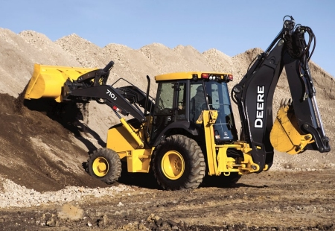

David Gaset

Trevor Nemrow

Michael Rufrano

10/10/13

EML 4024

Introduction
The following report will give a brief description of how SolidWorks was used to create a computer aided design “CAD” 3-D model of a backhoe loader. Using this program, individual parts of the backhoe were created, and then assembled into “sub-assemblies”. These sub-assemblies, were then mated together to create the final assembly. Once this was complete we began our kinematical analysis of the 3-D model and displayed the motions of certain points of interest. This was done in order to make sure the machine design is capable of reaching a practical and desirable range of motion.
The purpose of this project is to obtain a general understanding of the program, develop skills, and experience how 3-D modeling can be utilized in the engineering field. This project will display our knowledge of SolidWorks and present a fully functional model of a backhoe loader along with its range of motion. This report will show our Mechanical Design, a Model Analysis, and the Kinematic Capabilities of our model.

Mechanical Design
Our model of a backhoe loader consists of three main parts or “sub-assemblies”: the back arm, the tractor car, and the front loader. Along with the pieces of each part, we also designed hydraulic systems which were used multiple times within our design and adjusted the lengths accordingly. The basic design of the parts and assembly of the hydraulic system are shown in Figure 1.

Figure 1

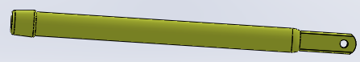

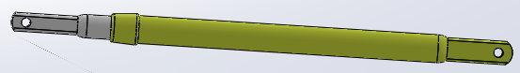

Our sub-assemblies and the parts that make them up are described in detail below
- Back Arm
Our first sub-assembly was the back arm. This sub-assembly is comprised of three main parts: the boom, the stick, and the bucket. The boom, shown below in Figure 2, has a joint on each end and two on its center.
Figure 2
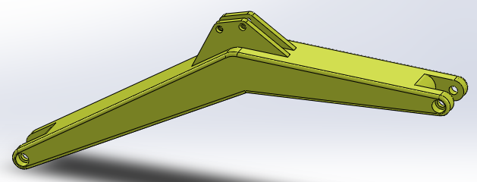

Attached to each joint are hydraulics, one of which allows the boom to pivot in a vertical 2-D manner about the point which connects to the tractor car and the other connects to the stick allowing the stick to pivot about the top of the boom.
The next part of the Back Arm is the stick. The stick has three joints attached at one end which connects it to the boom and two hydraulic systems: one controlling its motion relative to the boom and the other controlling the motion of the bucket. At the other end are the joints which connect the stick to the bucket. The stick is shown below in Figure 3.
Figure 3
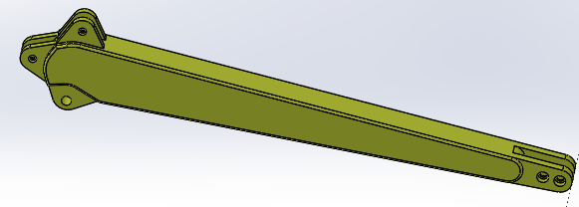

The last part of the back arm is the bucket. The bucket has a rotational range of motion about its connection point with the stick. We designed a hooking joint mechanism at the hydraulic to give the bucket enough clearance to obtain a desirable range of motion within its 2-D plane. The design is displayed below Figure 4.
Figure 4
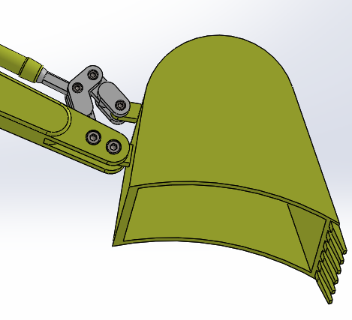

Once all these parts were created, they were then assembled into our “Back Arm” sub-assembly. Figure 5 shows our exploded view of the sub-assembly along with the collapsed view of our completed “Back Arm”
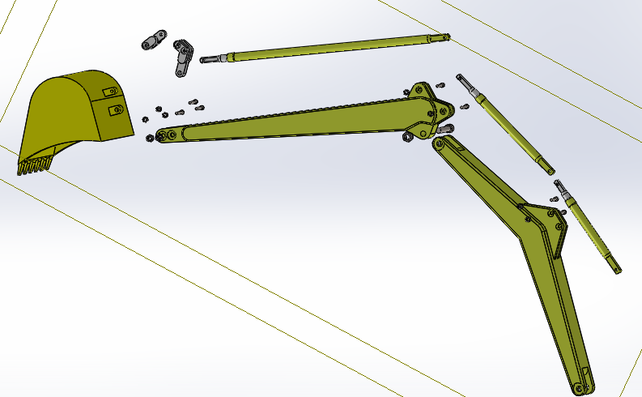
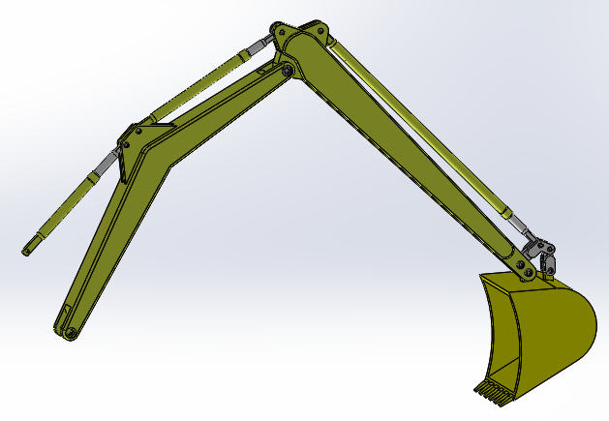
Figure 5

2.) Tractor Car
The next sub-assembly of our model is our tractor car. This was made with three main parts: the car, the pivot piece, and the stabilizer legs. The car was made as one rigid body and acts as our stationary frame to our model. We designed mounting brackets large enough for the other parts to obtain clearance when going through their ranges of motion. The tractor car can be seen below in Figure 6.
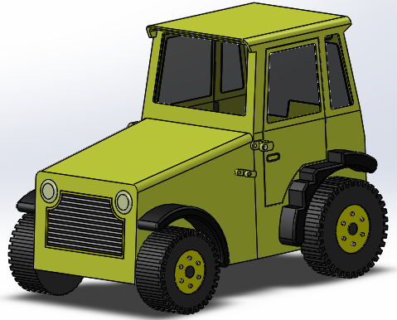
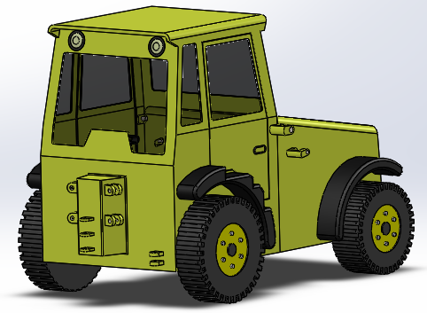
Figure 6

The pivot piece is attached to the back of the car. Its function is to swivel the back arm in a horizontal plane using a hydraulic system. This feature is shown below in Figure 7.
Figure 7
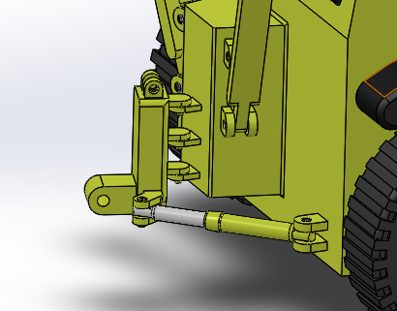

The stabilizer legs were then attached to the back arm connector. They come down to the floor to stabilize the machine when carrying heavy loads if necessary. The hydraulic system that extends the legs is shown in Figure 8.
Figure 8
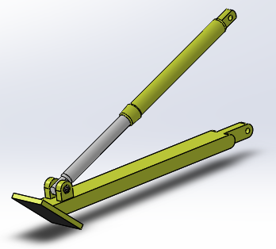

After completing each of these parts, they were then brought together to form our “Tractor Car”. Figure 9 shows our exploded view of the sub-assembly along with the collapsed view of our completed “Tractor Car”
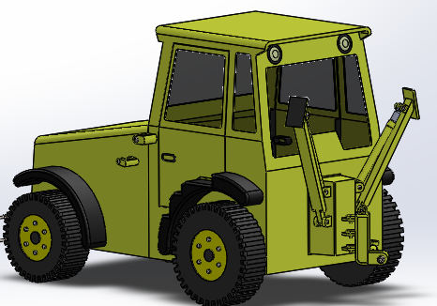
Figure 9
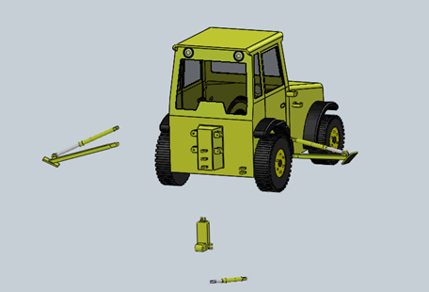
3.) Front Loader
The final sub-assembly is the front loader. This is comprised of two main parts: the loader arms and the loader bucket. The loader arms are attached to the side of the tractor car and extend towards the front of the car. The purpose of these arms is to lift the loader bucket up though use of hydraulics. The loader arms are shown below in Figure 10.
Figure 10
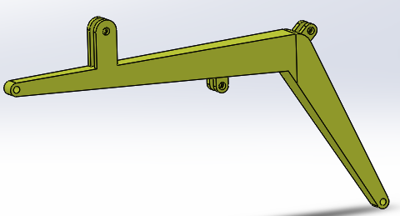

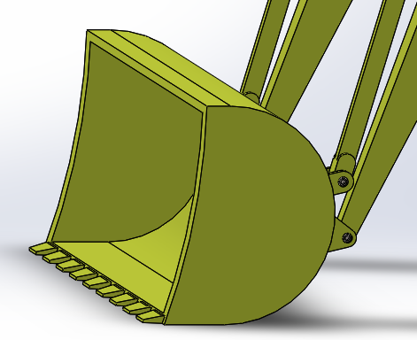
Figure 11
The loader bucket is similar to the bucket found in the back arm. It has a rotational range of motion just as the other bucket does and is attached to the loader arms with hook joint mechanisms as well. The loader bucket is shown in Figure 11.

Figure 12 shows our exploded view of the loader arms, sub-assembly, and the collapsed view of our completed “Front Loader”
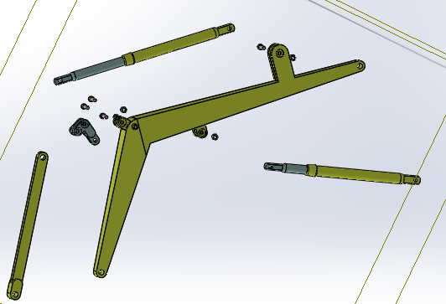
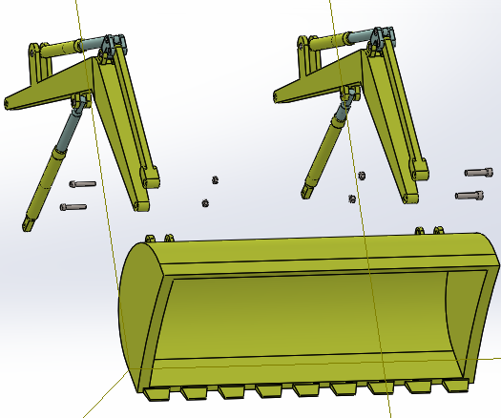
Figure 12
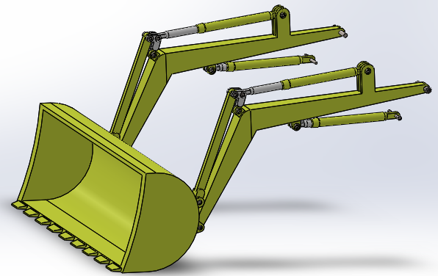

Finally all of our sub-assemblies were mated together, completing our 3-D model. Our completed mechanism is displayed in Figure 14.
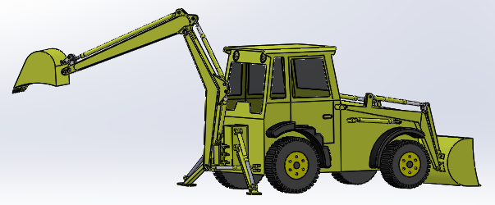
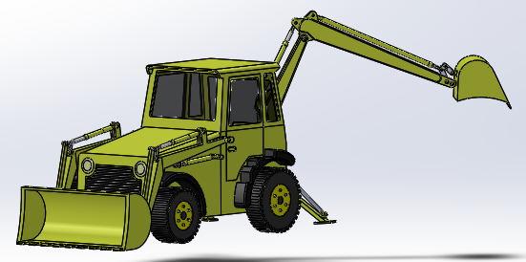
Figure 14

Mechanism Model Analysis
When choosing a material for our model, we found that steel is the most practical based on its strength, weight, and cost. All parts of the backhoe are made of steel except for the tires and the fenders which are made of rubber and plastic respectively. Table 1, shown below, displays the mass properties of each individual piece. Note that because the body was made as one, solid, non-moving part, its mass’ value is not truly represented. This is because the program is interpreting the inner cab as a solid body instead of open space.
Table 1
Sub-Assembly | Mass (lbs) | Volume (in³) | Surface Area | Materials
Body | 24324.66 | 673304.59 | 72989.32 | Steel/Rubber/Plastic
Back-Hoe | 864.66 | 23933.6 | 20937.26 | Steel
Front Loader | 754.32 | 20879.47 | 26002.20 | Steel
Total | 25948.33 | 718250.36 | 120373.35

Kinematics and Dynamics
In order to perform our motion study, we utilized our series of hydraulic systems. By placing linear motors on all our hydraulic shafts, we were able to manipulate our mechanism into reaching desired ranges of motion. After observing the motions of the pieces, we were then able to go back and make adjustments to our design such as increasing bracket sizes and positions in order to meet clearance values. This step of trial and error allowed us to optimize our design and obtain a desirable and effective range of motion. Points of interest were then chosen and their displacements were analyzed through solid works motion analysis software. The points chosen were on the front loader bucket, and the backhoe bucket. These two points are crucial to the application of the backhoe loader as they are where external loads are directly applied to. The analysis and results can be seen below. (Note that the blue lines represent the x direction, the red line represents the y direction, and the green line represents the z direction.)
Front loader bucket
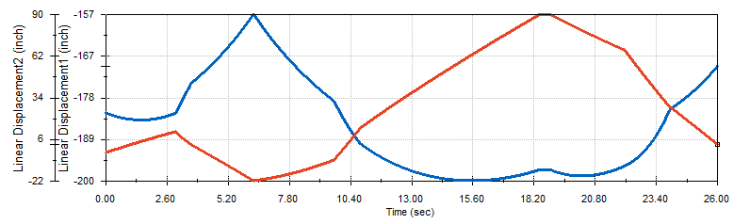
Displacement

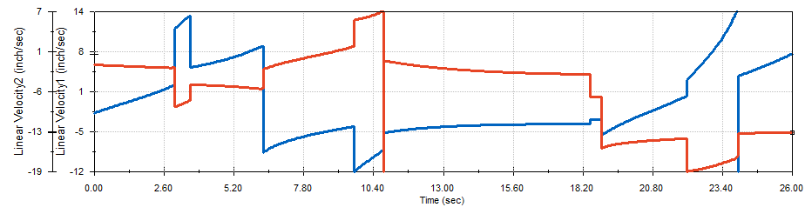
Velocity
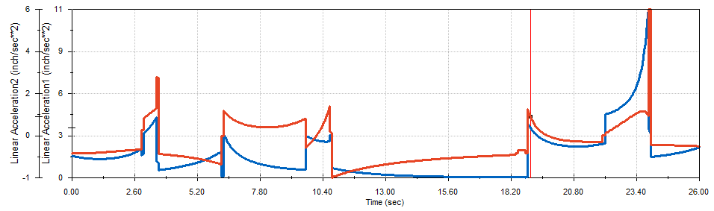
Acceleration
Backhoe bucket
Displacement
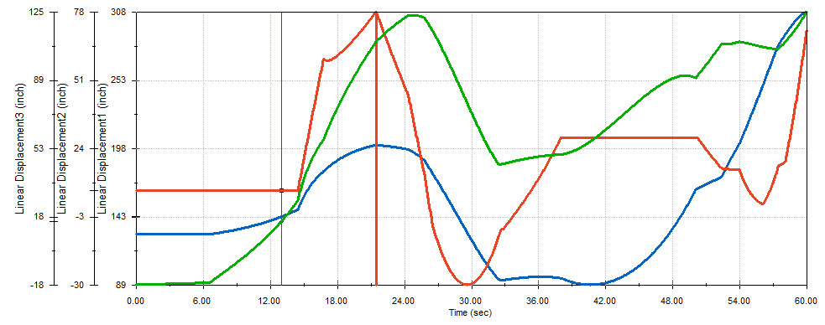

Velocity
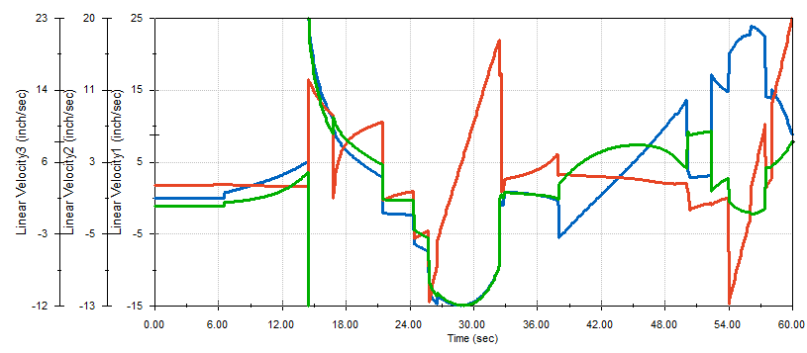

Acceleration
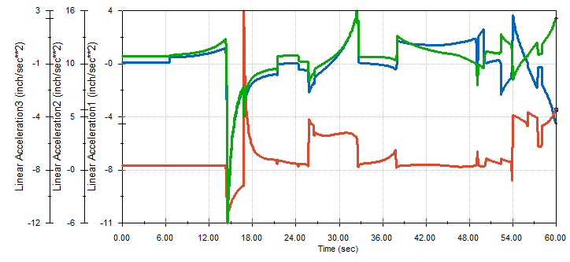

Conclusion
Within this project, many different techniques were learned in class and then applied to the project in order to create a working 3-D model of a backhoe loader. Using SolidWorks, each individual part was created through sketches, extrusions, patterns, and many other features. These parts were then assembled into sub-assemblies and eventually those sub-assemblies were mated together to create the final product. Finally constraints were applied and the design was checked and then double checked for errors. As seen above, the model’s range of motion fits a desirable range and will be able to complete the tasks that a machine like this will be faced with.
SolidWorks has proven to be an exceptional program for designing 3-D models. Throughout the duration of this project, the group members have developed a strong foundation of skills within the program. Also, this project has improved each group members, team work skills, which are necessary for modern day engineers. Overall, the design and analysis of the backhoe loader has proven our ability to cooperate as a group and create a working CAD model in SolidWorks.

