All-terrain Mobility Chair CAD

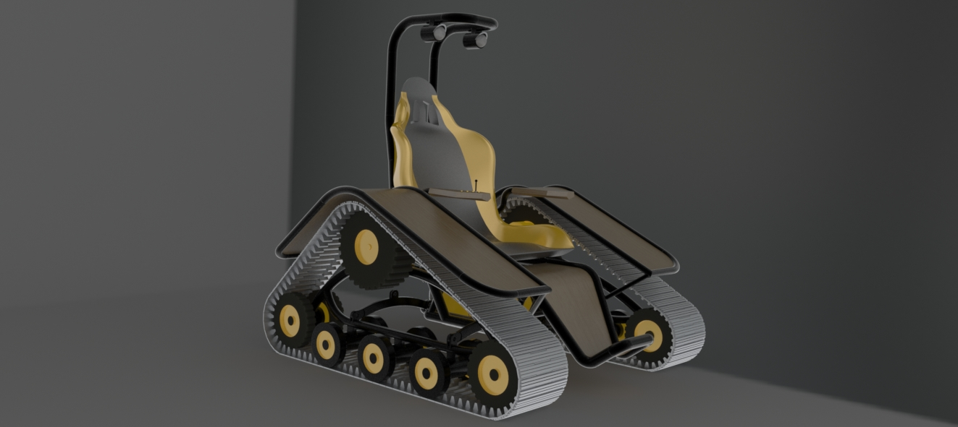

David Gaset

Trevor Nemrow

Michael Rufrano

12/5/13

EML 4024

Introduction

The following report will give a brief description of how SolidWorks was used to create a computer aided design “CAD” 3-D model of an “All-terrain Mobility Chair“. An All-terrain Mobility Chair is a one manned vehicle designed to travel across rough terrain with ease. Using this program, individual parts of the vehicle were created, and then assembled into “sub-assemblies”. These sub-assemblies, were then mated together to create the final assembly. Once this was complete material properties were assigned to the model and a kinematical analysis was performed in order to display the motions of certain points of interest of the vehicle. Finally a Finite Element Model “FEM” was applied to the CAD and a structural analysis was performed to ensure the integrity of the design.
The purpose of this project is to utilize our skills with SolidWorks in order to create a fully functional 3-D model of our choosing. We chose to model an All-terrain Mobility Chair based on the difficulty of the design and the ingenuity of the vehicle. This report will show our Mechanical Design, a Model Analysis, the Kinematic Capabilities of our model, and a Structural Analysis of our design.

Mechanical Design

Our model of the All-terrain Mobility Chair consists of three main parts or “sub-assemblies”: the frame, Left Drive, and the Right Drive. Our sub-assemblies and the parts that make them up are described in detail below

- Frame

Our first sub-assembly was the frame. The purpose of this sub-assembly is to act as the backbone structure of the vehicle. It is comprised of six parts: the chair, the bottom frame, and four batteries.
The chair is where the driver will sit and is equipped with head lights, and a control panel at the right arm-rest. The chair was created using the Boundary Boss/Base tool. The bulk of the chair is made of plastic, while the foot rest is made of mahogany wood. This piece can be seen in more detail below in Figure 1.

Figure 1
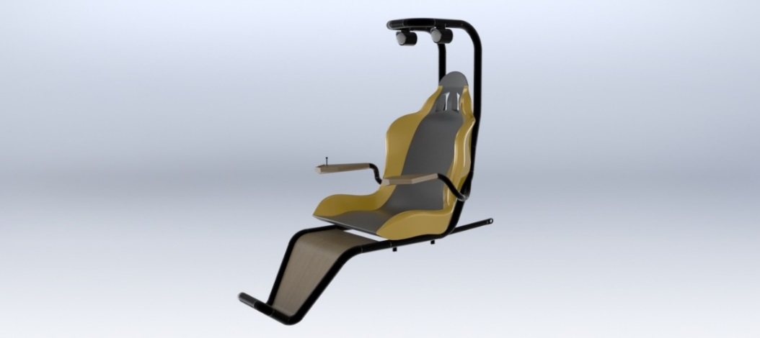

The next piece of the sub-assembly is the bottom frame. This piece acts as the backbone structure of the sub-assembly and will connect this sub-assembly to the other two. It has hinges toward the back which swivel the chair piece in order to access the batteries. It also has a bottom compartment which hole the batteries in place. At its two sides, there are two joints which will connect to a connecting rod which then connects to the Left and Right Drives. The bottom frame can be seen below in Figure 2.

Figure 2
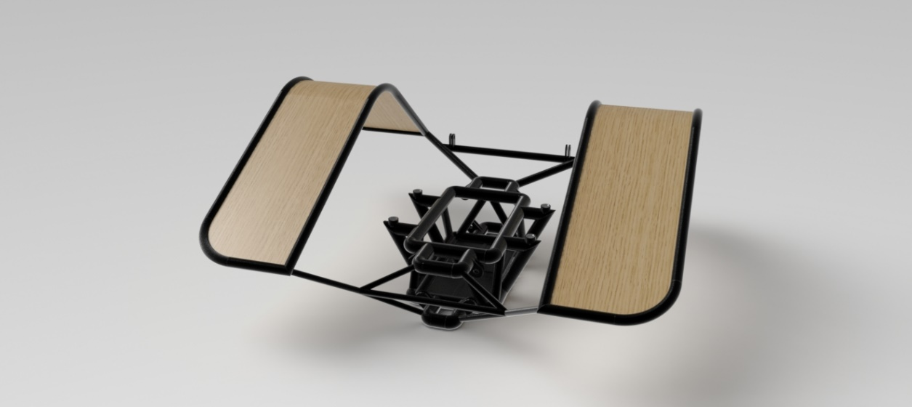

The last aspect of the “Frame” sub-assembly are the batteries. This is where the actual vehicle will get its power source. The design of our vehicle requires four of batteries. Figure 3 seen below, shows a basic CAD design of what the batteries will look like.

Figure 3
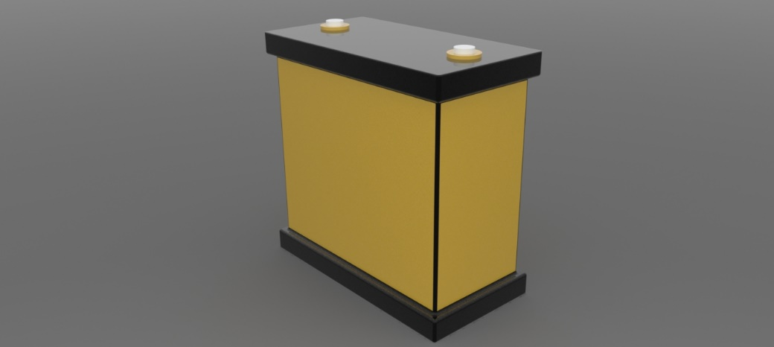

Once all these pieces were created they were brought together to form out complete “Frame” sub-assembly. The complete sub-assembly is displayed below in Figure 4.

Figure 4

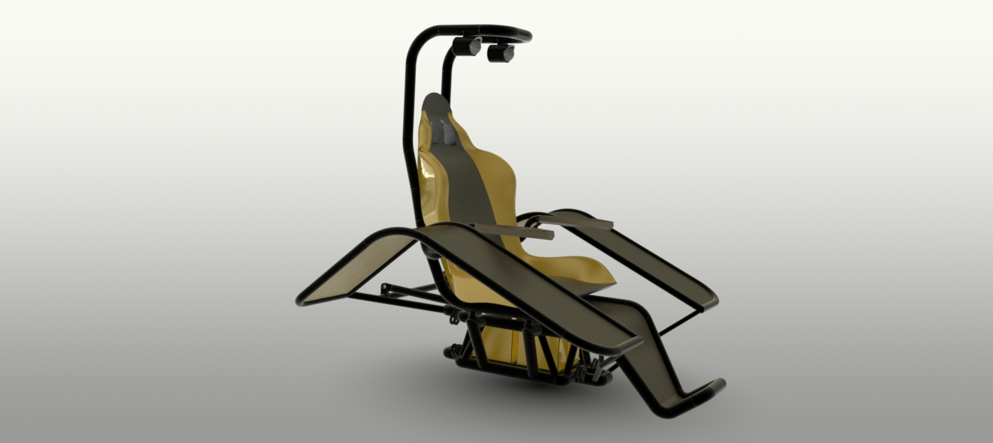

- Left Drive

The next sub-assembly is the Left Drive. This sub-assembly is more complex then the previous one. It consists of fifteen parts, each of which will be described in more detail below.
The first piece of the sub-assembly is the rigid frame. This piece acts as the backbone of the “Drive” assembly. It connects to the “Frame” assembly via spring systems and holds the wheels of the Drive in place. The piece is made of aluminum and can be seen in more detail below in Figure 5.

Figure 5
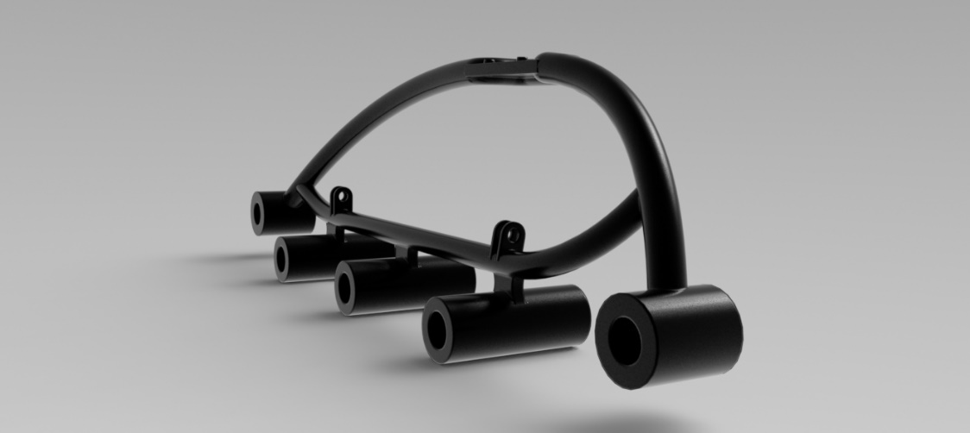

The next piece of the sub-assembly is the motor. The motor is what drives the entire vehicle forward or backward. It consists of the actual motor and the motor shaft which fits into the driving wheel. The motor can be seen in Figure 6.

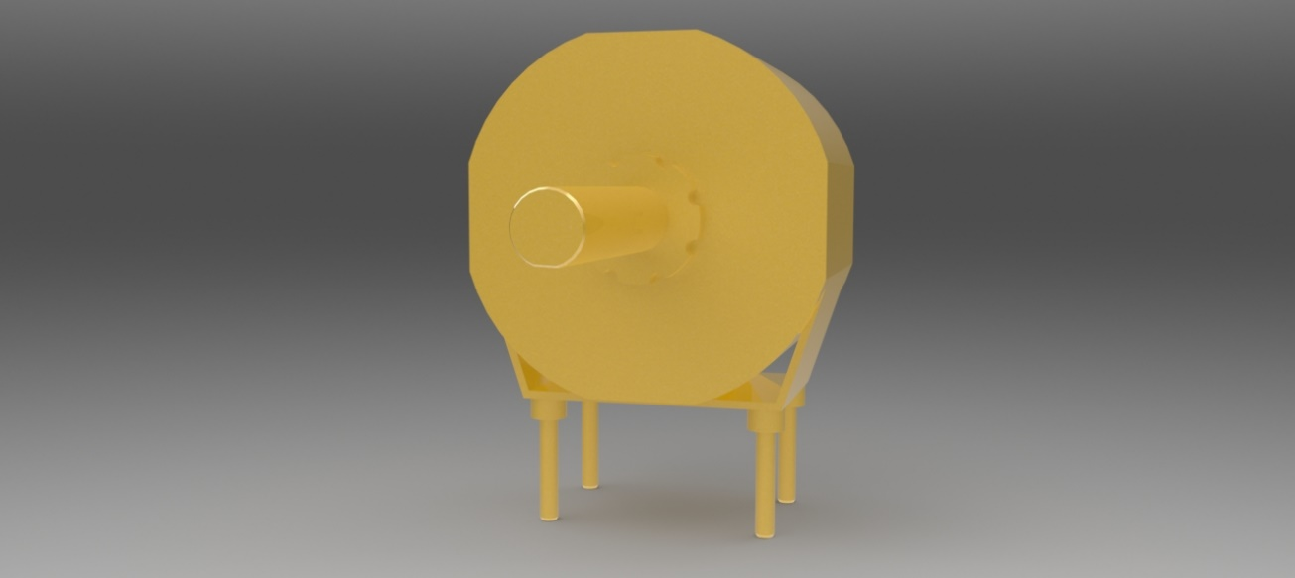
Figure 6

The next piece is the driving wheel. It fits onto the driving shaft and applies the main driving force onto the treads. The teeth of the wheel fit into the teeth of the treads to push them forward as the motor turns it. It is displayed below in Figure 7.

Figure 7

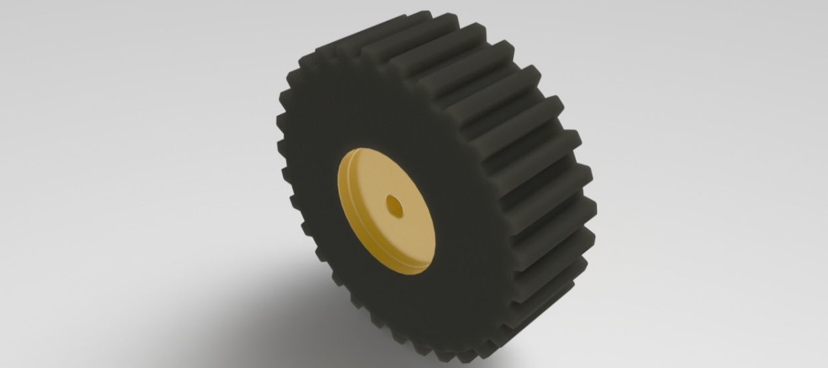

Next we have the inner and outer supporting wheels. The inner ground wheel contains the axle that fits into the mirrored outer wheel to from a functional wheel system for the treads to travel along. This wheel system is located at the bottom corners on the triangular track of the tread and have teeth which catch the teeth of the track at different locations due to the difference in radii compared to the driving wheel. These two companion pieces can be seen below in Figure 8.
Figure 8
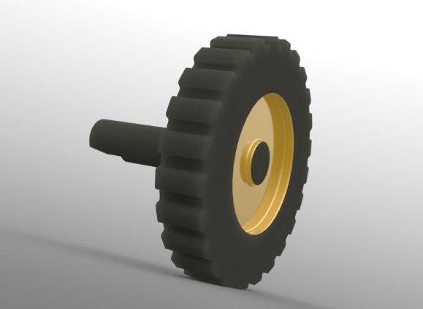
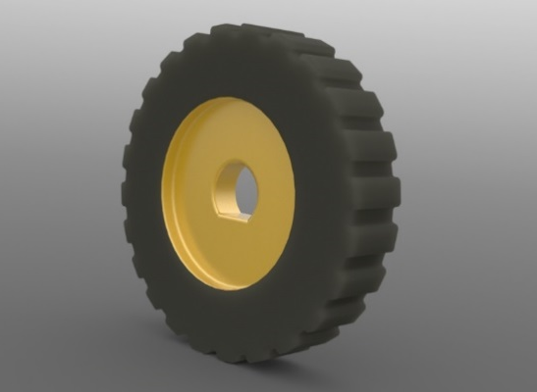

The next aspect of the “Left Drive” sub-assembly are the inner and outer ground wheels. Similar to the supporting wheels, the inner ground wheel has the axle that fits into the outer ground wheel. These wheels do not contain teeth however and just guide the treads along the bottom of the path from one supporting wheel to the other. There are three sets of the ground wheels between the two supporting wheels along the bottom of the sub-assembly. The two pieces can be seen in Figure 9 below.

Figure 9
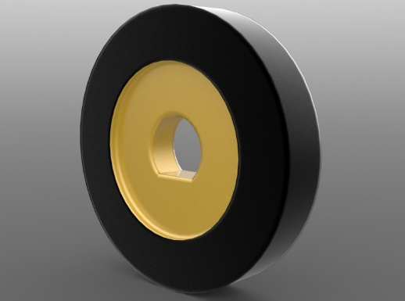
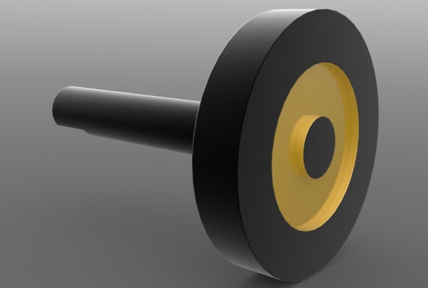

The last piece of the sub-assembly is the tread piece. This piece was designed to attach to duplicates of itself and combine to form the entire tread which wrap around the wheels to allow them to act as a sort of gear train. As the wheels turn they push the tread around its track. The outside of the tread catch the ground as it travels through its track and propel the vehicle forward or backward. A single tread piece is shown in Figure 10 below.

Figure 10

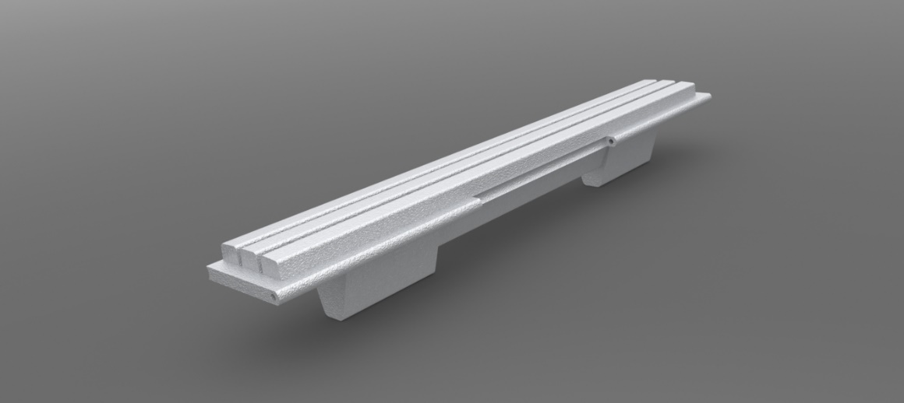

Once all these pieces were created, a sketch was designed in order to figure out the final assembly of our “Left Drive.” Many calculations were performed on the sketch in order to ensure smooth transitions among the different pieces of the sub-assembly. Final adjustments were then made to the previous pieces and finally were brought together to form the “Left Drive.” The “drive sketch” completed sub-assembly is displayed below in Figure 11 & 12.

Figure 11

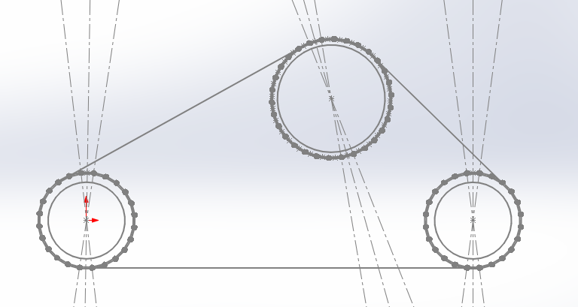

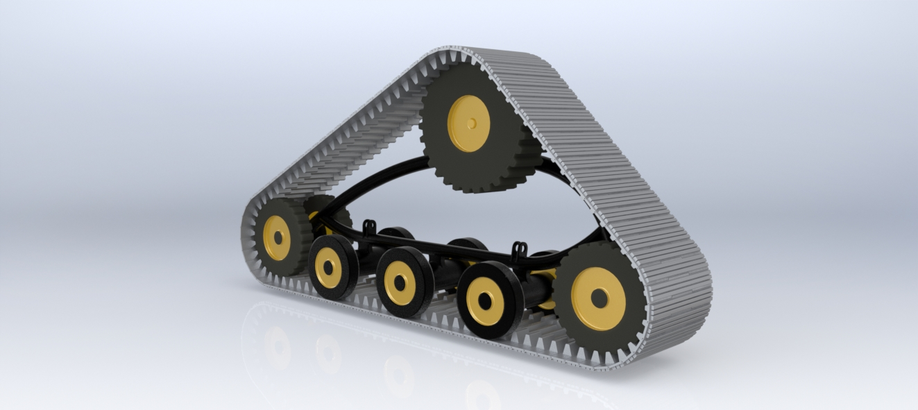
Figure 12

- Right Drive

The Right Drive is identical to the Left Drive. It was created by mirroring the entire assembly about the front plane and then flipping the orientation to match the symmetry of the vehicle.

- Master Assembly

Once all the sub-assemblies were complete, we were able to combine them into our master assembly. Using two connecting rods on each side, the Frame was connected to each of the Drive. Four connecting rods were used in total and can be seen below in Figure 13.

Figure 13
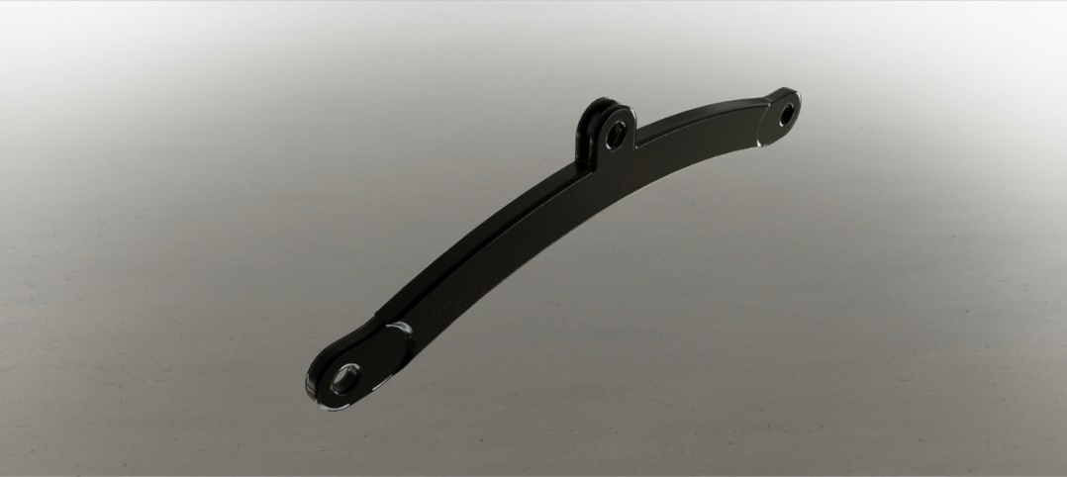

The complete master assembly can be seen in Figure 14.

Figure 14
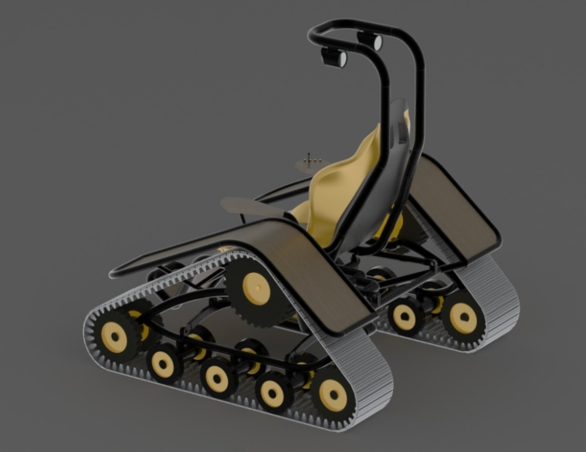
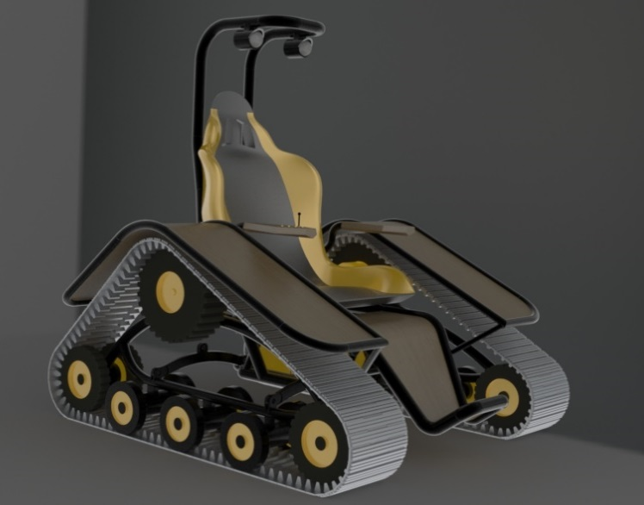

Mechanism Model Analysis

When choosing a material for our model, we found that aluminum is the most practical for all the frame components. Aluminum is strong enough to hold the expected loads of a driver and light enough to not weigh the vehicle down too much. The Chair was made out of PS medium high flow plastic. The fenders, foot rest, and arm rests, are made of mahogany wood and the treads are made from rubber. Table 1, shown below, displays the mass properties of each individual piece.

Table 1

Sub-Assembly | Mass (lbs) | Volume (in³) | Surface Area (in²) | Materials
Frame | 178 | 5,407 | 18,943 | Aluminum, Mahogany, Plastic
Left Drive | 316 | 3,545 | 12,180 | Aluminum, Natural Rubber
Right Drive | 316 | 3,545 | 12,180 | Aluminum, Natural Rubber
Total | 820 | 12,595 | 43,736

Kinematics and Dynamics

In order to perform our motion study, we utilized a system of springs and dampers attached from the frame to the drives. By inputting an allowable clearance value between the fender and the tread track prior to the motion study we were able find an acceptable spring constant value to use based on the expected loads applied to the chair. Once these values were obtained we were able to manipulate our vehicle through our desired ranges of motion ensuring that the fender does not impact the treads. A point of interest was then chosen on the chair and its displacement was analyzed and graphed through solid works motion analysis software. We showed the displacements, velocity, and acceleration of the point of interest along the global y direction. We also displayed the velocity and acceleration of the distance between the two drive wheels in relation to each other. (seen in red) The analysis and results can be seen below.

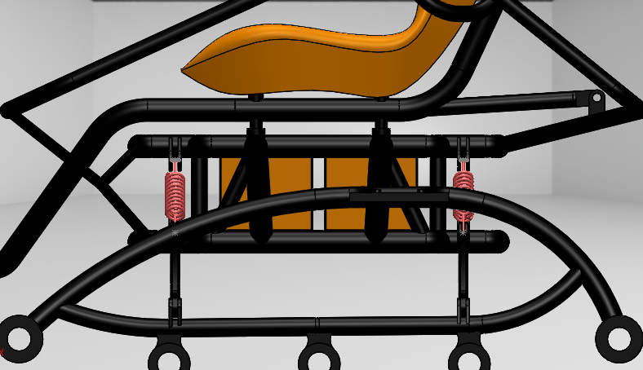

Displacement
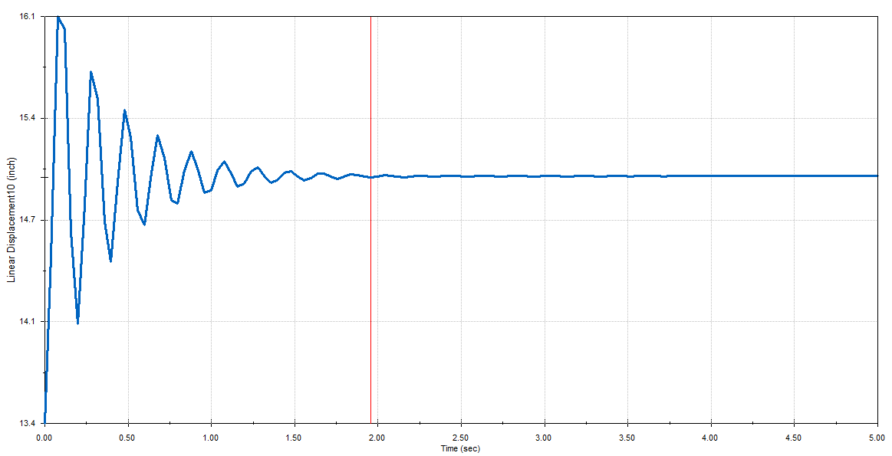

Velocity
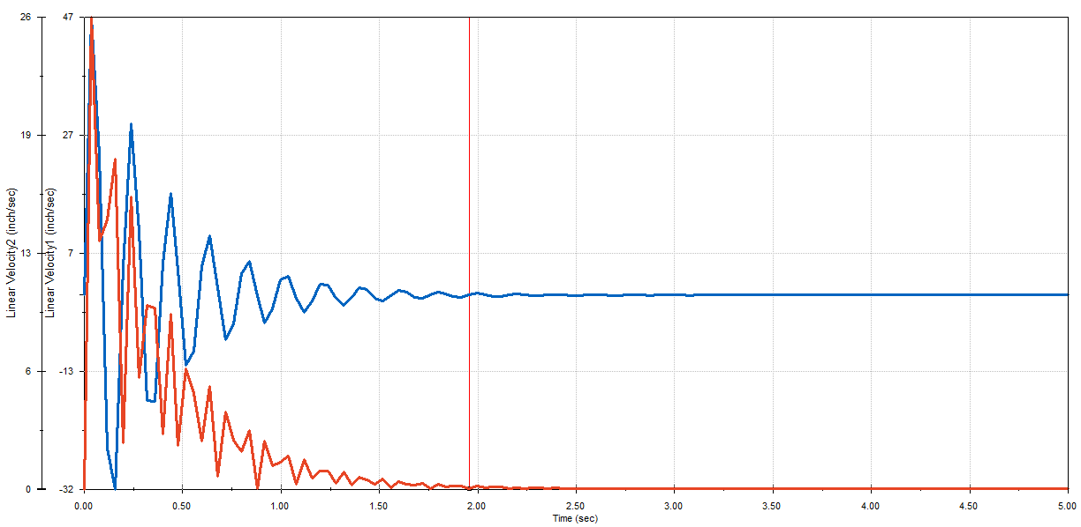

Acceleration
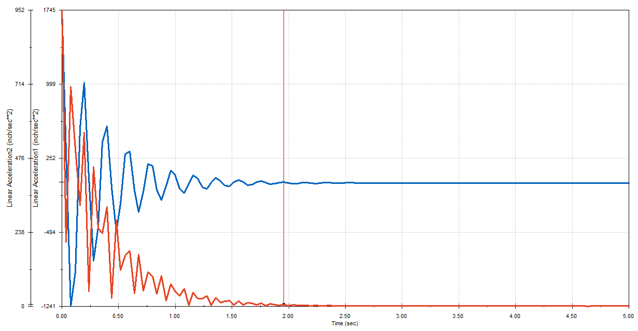

Structural Analysis

A finite element method or FEM was then applied to a tread piece of the drive wheels. We chose to perform the analysis on this piece because it will feel the total weight of the vehicle. The test was run at three different positions, at the contact of the drive wheel, the supporting wheel, and the ground wheel. We first applied a fix constraint. We then applied the force equivalent to the weight of the vehicle to the faces of contact between the tread piece and the wheels. Then a mesh was applied and the simulation was run. The results shown below show the stress, strain and displacement fields of all three positions.

Position 1

This position is when the tread is in contact with the drive wheel. As expected the displacement and stress is maximized at the center of the tread. The figures shown below display the stress, strain, and displacement fields.
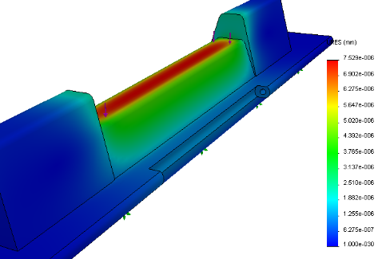
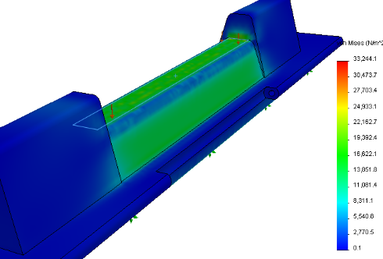
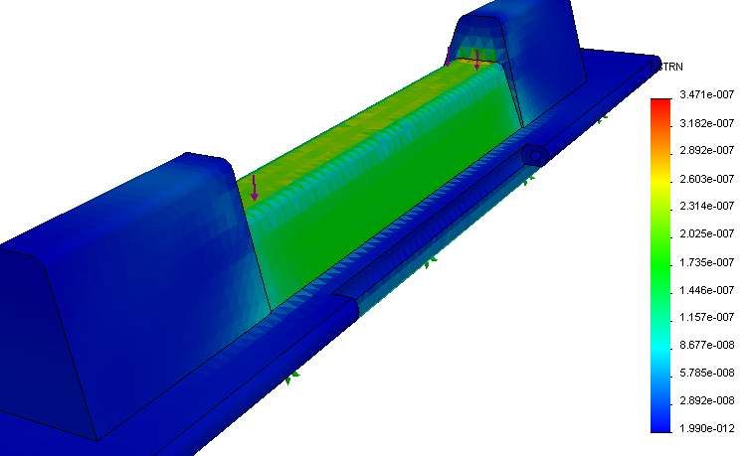
Position 2

This position is when the tread is in contact with the ground wheel. Here, the displacement and stress is maximized at the outside of the tread. This is expected because the is felt where the wheel comes into contact with the tread. The stress is concentrated at the holes of the tread because of the notch applied. The figures shown below display the stress, strain, and displacement fields.

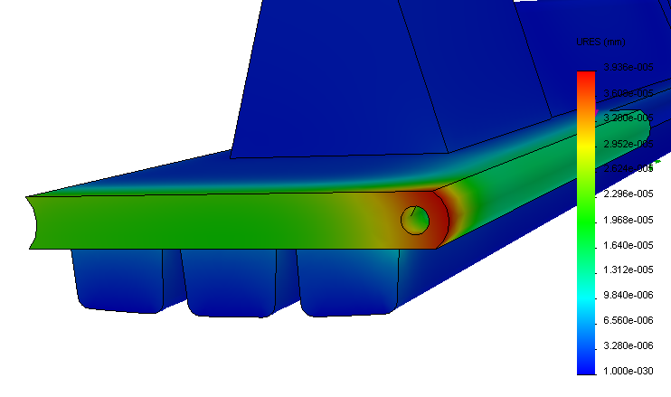
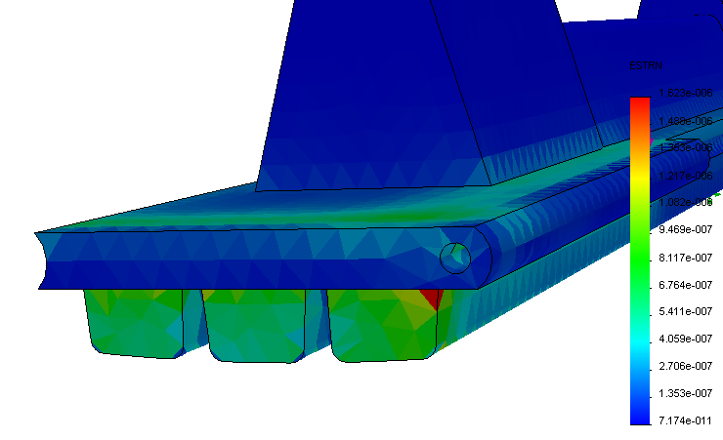
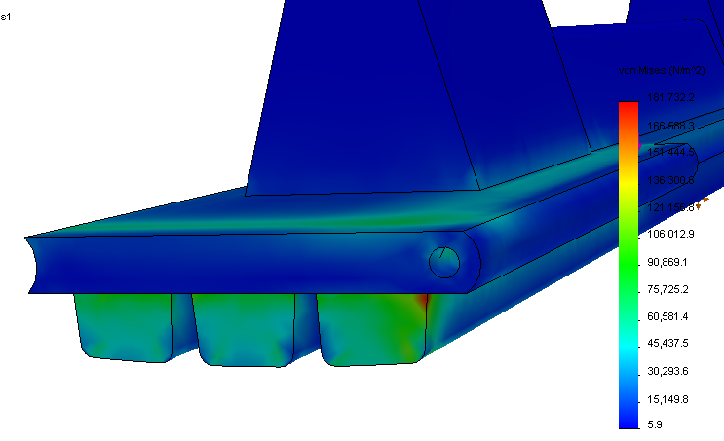

Position 3

This position is when the tread is in contact with the supporting wheel. At this position the stress is maximized at the top of the teeth where the wheel catches the piece. Here you can see a strong stress notch at the center of the top of the tooth. The figures shown below display the stress, strain, and displacement fields.

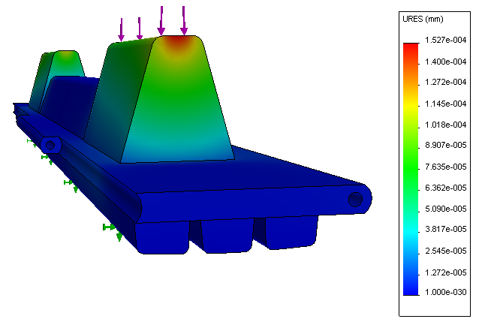
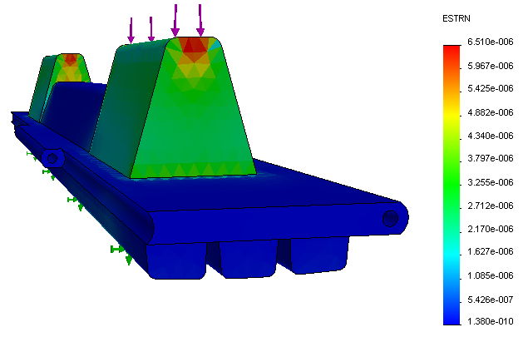
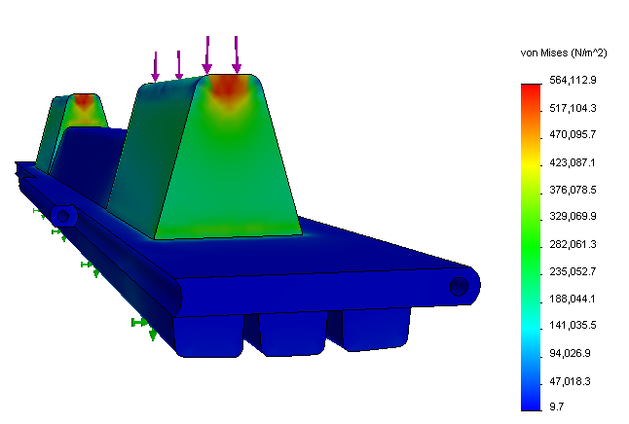

Conclusion

Within this project, many different techniques were learned in class and then applied to the project in order to create the working 3-D model of the All-terrain Mobility Chair. Using SolidWorks, each individual part was created through sketches, extrusions, patterns, and many other features. These parts were then assembled into sub-assemblies and eventually those sub-assemblies were mated together to create the final product. Finally constraints were applied and the design was checked for errors.
As seen above, the model’s range of motion fits a desirable range and will be able to complete the tasks that a machine like this will be faced with. We also found through our structural analysis, that the structure can withhold the expected strain levels that it will most likely encounter without failure.
SolidWorks has proven to be an exceptional program for designing 3-D models. Throughout the duration of this project, the group members have displayed a strong foundation of skills within the program. Overall, the design and analysis of the All-terrain Mobility Chair has proven our abilities in creating working CAD models and analyzing these models through the use of SolidWorks.

